We can use EPCS64 save NIOS II SOPC program . But you need know how to do . You must need add tri_state_bridge, cfi_flash and epcs_flash_controller. cfi_flash don.t need to give FPGA pin io, but EPCS need give FPGA io .
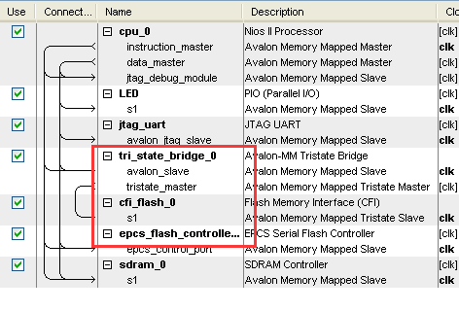
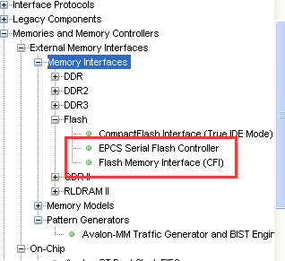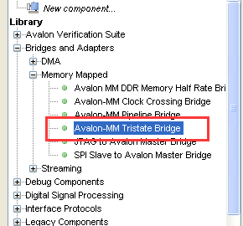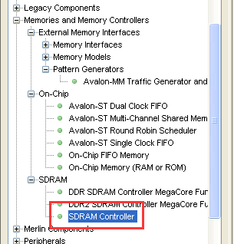

You need to QuartusII setup ,Pls you must do it .
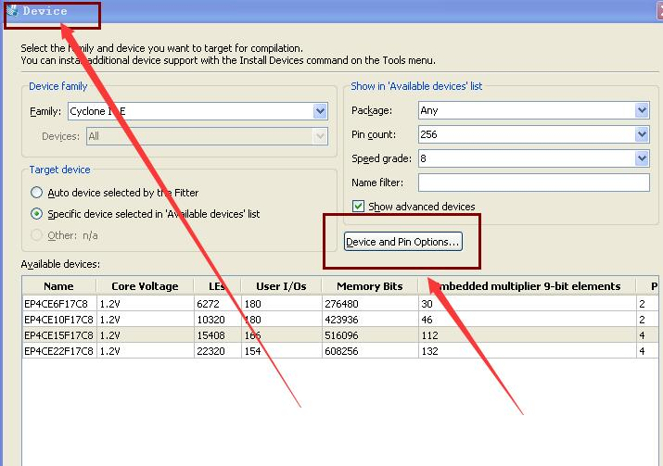
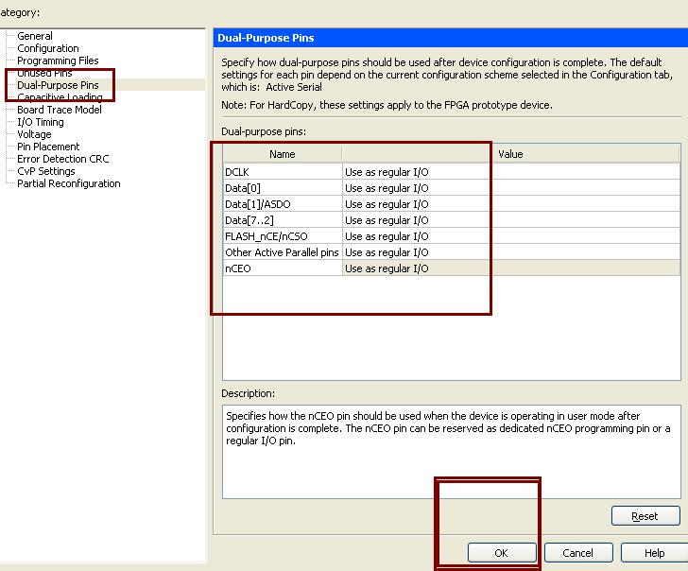
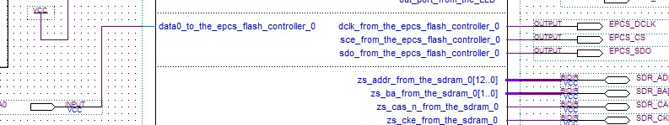
EPCS_CS | Output | PIN_D2
EPCS_DATA0 | Input | PIN_H2
EPCS_DCLK | Output | PIN_H1
EPCS_SDO | Output | PIN_C1

Pls you must do it .

